Lab 3
Date Assigned: 9/21/2015
Lab Report Due: Midnight 9/28/2015 on iLearn

- You may want to bring your textbook to labs to look up syntax and examples.
- Have a question? Ask your instructor for help, or look at the book or past lecture slides.
- We encourage you to talk to your classmates; it's okay to discuss ideas (but NOT copy code) during lab.
- You probably won't finish all of the exercises. Do as much as you can in the allotted time. You NEED to finish the rest after you leave the lab.
- Before you leave, SHOW your work to your instructor to get credit for your work in lab.
- Complete all sections and turn in a report to iLearn before the deadline. See turn-in check list (at the end of this document) for more details.
- For each lab, lab attendance and your work during lab 40%, lab report 60%.

Section 1: Absolute Path, Relative Path
What is a path?

A path is a sequence of directory names, usually leading to a file or directory.

A typical path in Windows looks like:
C:\Documents and Settings\Christopher\My Documents\My Pictures\funny.jpg

A typical path in Linux looks like:
/var/home/Christopher/documents/pictures/funny.jpg

Noted the two basic differences between Windows and Linux paths?
- A Windows path usually starts with a Drive letter like C: , while in Linux, the root directory of the system is symbolized using a slash (/)
- Windows paths use backslashes (\) while Linux paths use slashes (/)
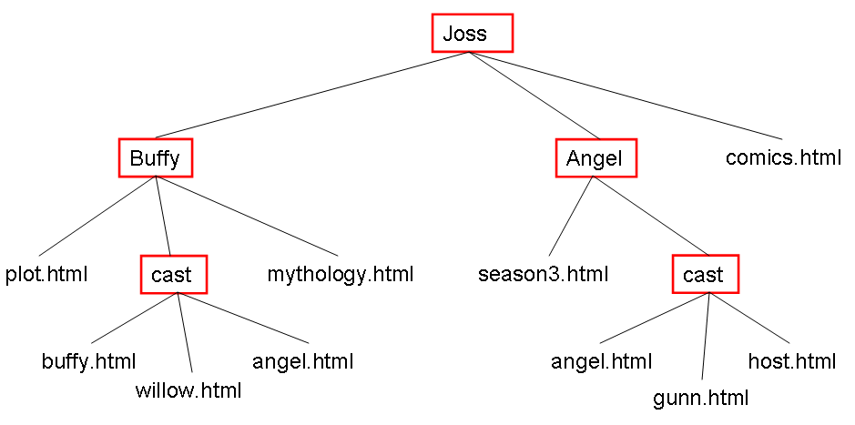
What is an absolute path?

An absolute path is a path that starts from the root of your computer system to your target file.
Example: Joss/Angel/cast/gunn.html

What is a relative path?

A relative path, is a path that is relative to your current file.
- If the target file is located in the same folder as the current file, the relative path would be just its name.
Example: Assume we are working on willow.html, and want to add a link to buffy.html. Since buffy.html is in the same folder, the relative path would be: buffy.html

- If the target file is in a sibling folder of the current file (that is, a subfolder of the current folder), the relative path would start from the sibling folder.
Example: Assume we are working on comics.html, and want to add a link to season3.html. Since season3.html is in folder Angel which is a sibling of comics.html, the relative path would be: Angel/season3.html

- If the target file is in a folder above the current folder? We need to move up one folder by putting two periods and a slash (../) in front of the relative path. We can use ../ as many times as we need to.
Example: Assume we are working on host.html, and want to add a link to season3.html. Since season3.html is in folder Angel which is above the current folder cast, the relative path would be: ../season3.html

When do we use absolute path or relative path?

Linking files on different servers requires the use of the absolute path. You may also use the absolute path for linking local files. Relative paths can only be used for links to local files.

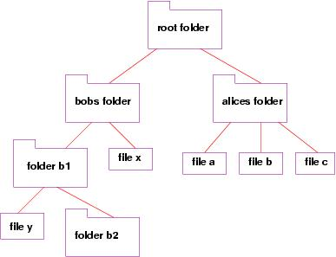

- Write down the absolute path to file y, file x, and file c.
- Assume you are working on file a, write down the relative path to file b.
- Assume you are working on file x, write down the relative path to file y.
- Assume you are working on file y, write down the relative path to file x.
- (Extra 2 points)Assume you are working on file a, write down the relative path to file x.
- (Extra 3 points)Assume you are working on file a, write down the relative path to file y.

Save your answers in a text/microsoft word file, and name your file Lab3Section1.txt/.doc/.pdf.

Section 2: CSS
Another major component of a web pages is CSS (cascading style sheets). CSS allows you to style your HTML and make it look however you please. CSS can be applied to HTML through an external .css file linked in the head of the HTML document.
<!DOCTYPE html>
<!-- My First Webpage -->
<!-- Author: Bowu Zhang -->
<!-- CMPT 120 Lab 3, August 31, 2015 -->
<html>
<head>
<meta charset="utf-8" >
<title>My First Webpage</title>
</head>
<body>
<h1>This is heading 1. We define the style of tag h1 in style.css. For example, we can specify the text color, font size, font family, and background color. </h1>
<h2>This is heading 2. We can specify multiple properties in CSS file for one tag at a time. </h2>
<p>This is a paragraph. Try as many style properties in style.css as possible.</p>
<img src="https://upload.wikimedia.org/wikipedia/en/8/8c/Marist_Red_Foxes_logo.png" alt="Marist College">
<a href="http://www.marist.edu">For more details about Marist College, Please Check out this link </a>
<ul>
<li>Check</li>
<li>Out</li>
<li>This List</li>
</ul>
<p>This is the end of example.</p>
<!-- this is a comment and is totally ignored by the browser-->
</body>
</html>
- Create a page csstest.html that includes code in the above example, and save it in lab3. View the page in Chrome.
- Your next step to making this page beautiful is adding an external stylesheet.
Start with a new blank file in Notepad++/Sublime Text2 and add this code:
body {
background-color: orange;
}

Save this file as style.css in your lab3 folder. Make sure your style.css file has an extension of .css, NOT .html.
- Then, at the top of the csstest.html file, in the head section of the document, connect this stylesheet:
<link href="style.css" rel="stylesheet" type="text/css">
Reload the csstest.html page in the browser. Is the background orange? Excellent! You've successfully attached an external stylesheet. You can now remove the background-color:orange declaration in style.css (it was just for testing to confirm the connection worked.)
A CSS file, e.g., style.css, consists of styles. A style has two parts: a selector (which tags to apply the properties to) and a set of properties (how they should look).
selector {
property: value;
property: value;
/* you can add more properties */
}

For example:
body {
background-color: black;
color: white;
}

Selector:
The body selector selects all <body> tags that appear in a HTML file.

Properties:
background-color sets the background color of the section that this tag covers. The color is specified here by name (there are many other ways of specifying colors http://dev.w3.org/csswg/css3-color/, but we prefer name).
color sets the text color.

- Add the following styles into style.css. Then reload csstest.html in Chrome, and view the changes.
p {
font-family: Georgia;
font-size: 14px;
}
h1 {
text-align: center;
font-family: "Courier New";
}
h2 {
text-align: right;
}
Selector:
The p selector selects all <p> tags that appear in a HTML file.

Properties:
font-family sets a specific font such as Times New Roman, Georgia, Arial, and Courier New.
font-size sets the size of the text with pixels, e.g., 10 px, 20 px.

Selector:
The h2 selector selects all <h2> tags that appear in a HTML file.

Properties:
text-align is used to set the horizontal alignment of a text.Text can be centered, or aligned to the left or right.

- In style.css, change the value of property text-align in h1 from center to left. Reload csstest.html in Chrome, and view the changes.
- In style.css, add a property/value to h2: font-family: “Arial”;. Reload csstest.html in Chrome, and view the changes.
- In style.css, add a property/value to h2: font-size: 20px;. Reload csstest.html in Chrome, and view the changes.
- In style.css, add a property/value to p: color: green;. Reload csstest.html in Chrome, and view the changes.
- Add the following selector to style.css. Reload csstest.html in Chrome, and view the changes.
ul {
list-style-type: square;
}

- In style.css, change the value of list-style-type in ul from square to circle. Reload csstest.html in Chrome, and view the changes
- Read http://www.w3schools.com/css/css_intro.asp for CSS introduction.
- Read http://www.w3schools.com/css/css_syntax.asp for CSS format.
- Read http://www.w3schools.com/css/css_font.asp for font properties.
- Read http://www.w3schools.com/css/css_text.asp for text properties.
- Read http://www.w3schools.com/css/css_background.asp for background properties.
- Read http://www.w3schools.com/cssref/pr_list-style.asp for list properties.
- Add more styles into style.css to improve the appearance of csstest.html page in the format of
selector {
property: value;
property: value;
/* you can add more properties */
}

  - Change the color of at least two tags
  - Change the font properties (font-family, font-size, or font- style) of at least two tags. Some standard fonts: Arial, Arial Black, Verdana, Trebuchet MS, Georgia, Tahoma, Courier New, Times New Roman
  - Change at least one other thing (e.g. background color, text alignment, etc.)
Section 3: Validation of CSS
- Open https://jigsaw.w3.org/css-validator/. Either click Validate by File Upload and then Browse to your style.css file, or click Validate by Direct Input and then copy/paste your code into the text box. If there are any errors, fix errors, then repeat the previous steps.

TURN-IN CHECKLIST:

- Lab3Section1.txt/.doc/.pdf created in Section 1.
- Source Code (.html/.css/.js files) created in this assignment. Remember to include your name, the date, and the lab number in comments near the beginning of your code.
- Create a folder and name it 'FirstName_LastName_lab_3'. In the newly created folder copy and paste your source code (.html/.css/.js files) and Lab3Section1.txt/.doc/.pdf . Then compress the folder, and upload it to iLearn.

